AI Interview / assignment questions

Part A: MCQ

Q1. There are 60 data points which are randomly split into 3 classes of equal size. All partitions are equally likely. A and B are two data points among them. What is the probability that two data points A and B will end up in the same class?

- 1/3

- 19/59 (correct answer)

- 18/58

- 19/60

Q2. A report is stating that a person is suffering from COVID-19 though he is actually not affected by coronavirus. Which of the following case is correct

- True positive

- False positive (Correct Answer)

- True negative

- False negative

Q3. Which of the following time series data can be declared as stationary?

(a) (b) (Correct Answer) (c)
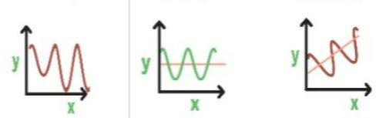

Q4.Consider the following training set of m=4 training examples:

- y

1 0.5

2 1

4 2

0 0
Consider the linear regression model h_{θ}(x)=θ₀+θ₁x. What are the values of θ₀ and θ₁ that you
​​ ​​ ​​ ​​ ​​

would expect to obtain upon running gradient descent on this model? (Linear regression will be

able to fit this data perfectly.)
​​ | ​​
(A) θ₀=0.5,θ₁=0 (Correct Answer)
​​ | ​​
(B) θ₀=0.5,θ₁=0.5
​​ | ​​
(C) θ₀=1,θ₁=0.5
​​ | ​​
(D) θ₀=0,θ₁=0.5
​​ | ​​
(E) θ₀=1,θ₁=1
Q5. Let f be some function so that
​​ ​​
f(θ₀,θ₁) outputs a number. For this problem,
f is some arbitrary/unknown smooth function (not necessarily the
cost function of linear regression, so f may have local optima). |  | ​​ | ​​
 | ​​ ​​ | ​​ | ​​
Suppose we use gradient descent to try to minimize f(θ₀,θ₁) as a function of θ₀ and θ₁. Which of the following statements are true? (Check all that apply)

Statement1: If and are initialized at the global minimum, then one iteration will not change their values. [Correct]

Statement2: Setting the learning rate to be very small is not harmful, and can only speed up the convergence of gradient descent.

Statement3: No matter how and are initialized, so long as is sufficiently small, we can safely expect gradient descent to converge to the same solution.

Statement4: If the first few iterations of gradient descent cause to increase rather than decrease, then the most likely cause is that we have set the learning rate to too large a value.[Correct]
- Statement 1 and Statement 2 are correct

- Statement 2 and Statement 3 are correct

- Statement 1 and Statement 4 are correct (Correct Answer)

- Statement 2 and Statement 4 are correct

Q6. What are the effects of pooling operation on a CNN based model

Statement1: Increase feature / dimensionality

Statement2: Reduce feature / dimensionality

Statement3: Performs down sampling operations

Statement4: Performs up sampling operations

- Statement 1 and Statement 3 are correct

- Statement 1 and Statement 4 are correct

- Statement 2 and Statement 4 are correct (Correct Answer)

- Statement 2 and Statement 3 are correct
Q7. Role of activation function

Statement1:Introduce non-linearity

Statement2: Delivers output based on linear combinations of inputs

Statement3: To learn complex patterns in data

- Statement 1 and Statement 3 are correct (Correct Answer)

- Statement 2 and Statement 3 are correct

- Statement 1 and Statement 2 are correct

- Only statement 1 is correct

Q8. Which of the following is a widely used and effective machine learning algorithm based on the idea of bagging?

- Decision tree

- Regression

- Classification

- Random forest (Correct Answer)

Q9. How do you handle missing or corrupted data in a dataset?

- Drop missing rows or columns

- Replace missing values with mean/median/mode

- Assign a unique category to missing values

- All of the above (Correct Answer)

Q10. Why is second order differencing in time series needed?

- To remove stationarity

- To find the maxima or minima at the local point

- Both A and B (Correct Answer)

- None of the above

Q11. When performing regression or classification, which of the following is the correct way to preprocess the data?

- Normalize the data -> PCA -> training (Correct Answer)

- PCA -> normalize PCA output -> training

- Normalize the data -> PCA -> normalize PCA output -> training

- None

Q12. Which of the following is an example of feature extraction?

- Constructing bag of words vector from an email

- Applying PCA projects to a large high-dimensional data

- Removing stopwords in a sentence

- All of the above (Correct Answer)

Q13. Which of the following is true about Naive Bayes ?

(A) Assumes that all the features in a dataset are equally important
- Assumes that all the features in a dataset are independent

- Both A and B (Correct Answer)

- None of the above options

Q14. Which of the following statements about regularization is not correct?

- Using too large a value of lambda can cause your hypothesis to underfit the data

- Using too large a value of lambda can cause your hypothesis to overfit the data

- Using a very large value of lambda cannot hurt the performance of your hypothesis

- None of the above (Correct Answer)

Q15. How can you prevent a clustering algorithm from getting stuck in bad local optima?

- Set the same seed value for each run

- Use multiple radom initializations (Correct Answer)

- Both A and B

- None of the above

Q16. In which of the following cases will K-means clustering fail to give good results? 1) Data points with outliers 2) Data points with different densities 3) Data points with nonconvex shapes

- 1 and 2

- 2 and 3

- 1,2 and 3 (Correct Answer)

- 1 and 3

Q17. Which of the following is a reasonable way to select the number of principal components "k"?

- Choose k to be the smallest value so that at least 99% of the varinace is retained (Correct Answer)

- Choose k to be 99% of m (k = 0.99*m, rounded to the nearest integer)

- Choose k to be the largest value so that 99% of the variance is retained

- Use the elbow method.

Q18. You run gradient descent for 15 iterations with a=0.3 and compute J(theta) after each iteration. You find that the value of J(Theta) decreases quickly and then levels off. Based on this, which of the following conclusions seems most plausible?

- Rather than using the current value of a, use a larger value of a (say a=1.0)

- Rather than using the current value of a, use a smaller value of a (say a=0.1)

- a=0.3 is an effective choice of learning rate (Correct Answer)

- None of the above

Q19. Consider​ the following neural network which takes two binary-valued inputs

and outputs . Which of the following logical functions does it (approximately) compute?
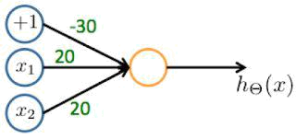

- NAND (meaning “NOT AND”)

- OR

- XOR (exclusive OR)

- AND (Correct Answer)

Q20. 3 people Alice, Bob and Charlie. Alice can shoot with probability 0.2, Bob with 0.5 and Charlie with 1. What is the probability of Bob surviving if they all were shooting in cyclic order.
- 1/10

- 13/30 (Correct Answer)

- 8/10

- None

Q21. Histogram equalization is not used for

- Image enhancement

- Image translation

- Contrast adjustment (Correct Answer)

- All

Q22. Which filter is advisable to remove salt and pepper noise

- Gaussian filter

- Median filter (Correct Answer)

- Averaging filter

- Contraharmonic mean filter

Q23. Which of the following color space doesn’t have a channel corresponding to luminosity of image

- RGB

- LAB

- HSV (Correct Answer)

- all

Q24. What is padding in image processing
- The process of removing noise from an image

- The process of modifying pixel intensity value of an image

- The process of adding layers of zeros to an image (Correct Answer)

- All

Q25. Second derivative of approximation says that value at the end of ramp must be

- Zero

- Nonzero (Correct Answer)

- Positive

- negative

Part B: Fill in the blanks with correct option

Q1. Information gain leads to ​……………decrease………….. ​(increase/decrease) in Entropy?

Q2. A decision tree is a ​………… nonlinear ………….​(linear/nonlinear) algorithm for
………… classification ………….. ​(classificationn /regression) which works by trying to
………… decrease …………...​(increase/decrease) entropy.

Q3. Logistic regression is used for​………… classification …………… ​(regression/classification)

Q4. K-Nearest Neighbours take more time for ​………… testing …………… ​(training/testing) less
time for ​………… training …………… ​(training/testing)

Q5. A table has 3 columns. First column has values ranging from -1 to +1. The second column has values ranging from 1 to 100. The third column has values ranging from 0 to +256. What should be the idle range of output ​…………-1 to 256…………… ( ​from 0 to +1, from

0 to 256, from -1 to 256)
Part C: Long Questions

Q1. Given the following english excerpt:

Steve was born in Tokyo, Japan in 1950. He moved to London with his parents when he was 5 years old. Steve started school there and his father began work at the hospital. His mother was a house wife and he had four brothers.

He lived in England for 2 years then moved to Amman, Jordan where he lived there for 10 years. Steve then moved to Cyprus to study at the Mediterranean University. Unfortunately, he did not succeed and returned to Jordan. His parents were very unhappy so he decided to try in America.

He applied to many colleges and universities in the States and finally got some acceptance offers from them. He chose Wichita State University in Kansas. His major was Bio-medical Engineering. He stayed there for bout six months and then he moved again to a very small town called Greensboro to study in a small college.

Perform the following in python and provide the code for the same:

- Text lowercase

- Change numerals to their counter names

- Remove punctuations

- Remove whitespaces

- Remove stopwords

- Stemming

- Lemmatize
Q2. You​ can use Python, Java, C, C++, and the opencv library for this task.

- You are given an image of 2 intersecting ovals. Write a program to fill the area of intersection with black.

- You are given an image with many basic geometric shapes (ovals/circles and polygons). The perimeters of these figures have been erased at places. Write a program to fill the gaps such that the perimeters have no discontinuities.

Here are the images that can be used as reference for the aforementioned tasks.
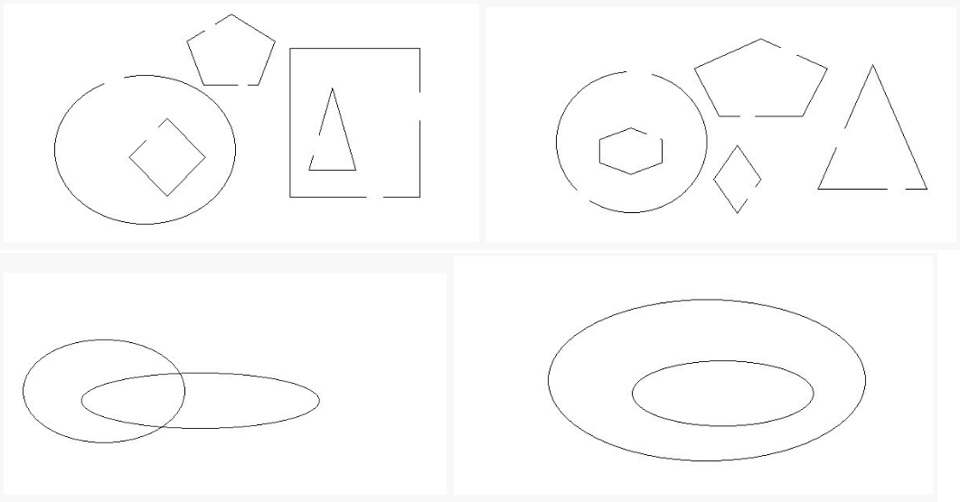

Q3. You can use any programming language in which you are comfortable.

Given a 2D array containing only zeroes and ones. whenever you find a zero fill that row and column with zeroes.

Q4. The ruler of byteland is selling the land of the kingdom.

Given the N number of rectangular coordinates (a,b) , (c,d) which are diagonally opposite, the rectangular area is in accordance with the rectangular axes.

Two area can overlap each other. Find the total area that King can sell.

1<=N<=20

-10000<=a,b,c,d<=10000

Example :

Input :

First line contains N and then following N lines contains values of a,b,c,d 2

0022

1133

Output :
7

- 2

- 7

- 4

- 3

Q5. Train a Noise Detector:

For this problem, you’ll need to set up your own google-collab and submit your solutions as a link.

- Please download ​training data​and ​validation data
- Upload them to your google-collab notebook.

- Use the training and validation datasets to train a machine-learning model, ​of your choice​, that could predict the “target” field with high accuracy, given other columns.

- You can use other languages like Matlab and R but ​preference​will be given to python.

- You are free to use any machine learning framework but ​preference​will be given to one of​scikit-learn, keras, tensorflow, pytorch​. You can also use ​numpy, seaborn, matplotlib, pandas​for data visualization and processing. Please ​refrain​from using any other packages.

- Note that the test data against which your model will be tested is not provided. So, please refrain from using the validation set for training as there is a risk of overfitting.
- Your submission will also be evaluated on ​replicability​, ​code-quality​, ​visualization​, analyses​, ​clarity​, and the ​accuracy ​on the test data. Please end your submission notebook by printing to the console an ​Accuracy Score on the Validation dataset and a confusion matrix​. Your conclusions, comments, and feedback are also welcome.

